Emperor penguin
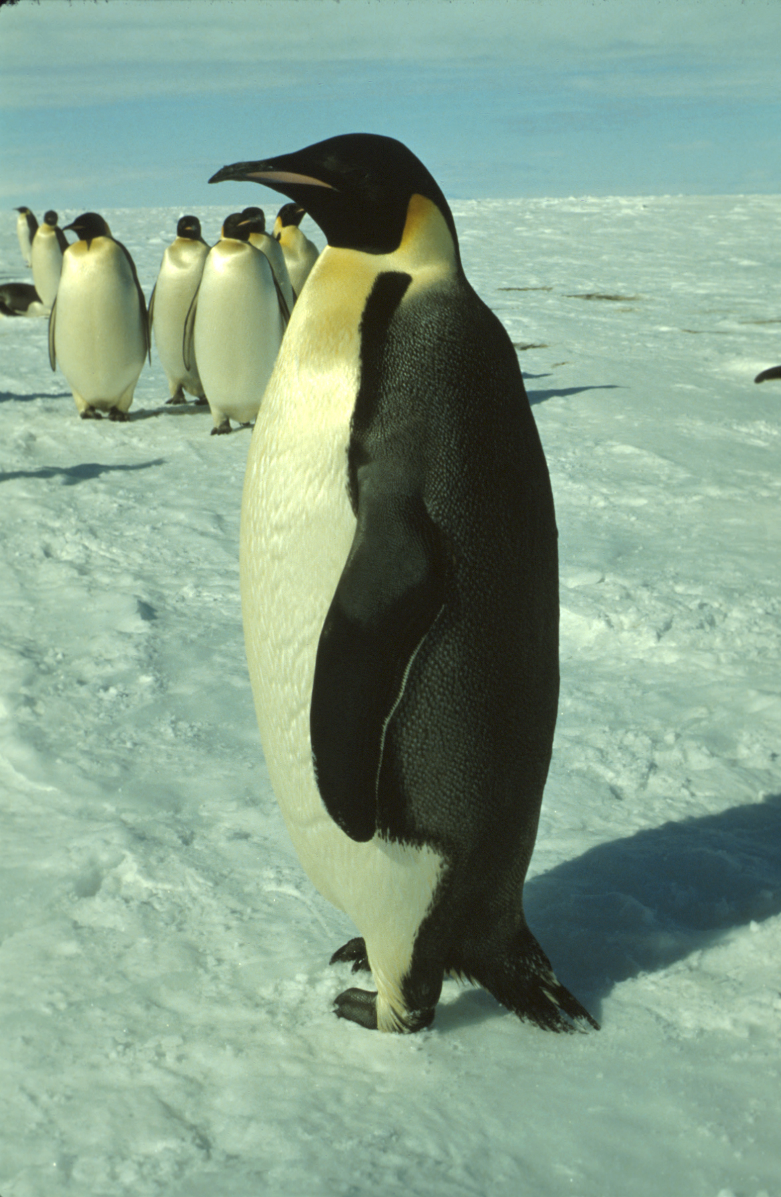
Emperor penguins are the largest living penguin. They can be up to approximately 1.1 metres tall and usually weigh between 30 and 40 kilograms. They not only live, but also breed on pack ice that is attached to the land, in Antarctica.
CSIRO, Penguin, http://www.scienceimage.csiro.au/image/7605
CC BY 3.0 creativecommons.org/licenses/by/3.0/
Emperor penguins can survive in Antarctica because their skin is covered with layers of feathers. These keep them warm and also act as insulation from the cold. Their blubber keeps them warm inside during the extreme conditions in Antarctica. The emperor penguin is also able to recycle its own body heat that it keeps re-warming internally. They have a very small bill and flippers to also help reduce loss of body heat.
Another factor that helps the emperor penguin survive is that it is extremely social and not territorial like many other animals. This means they can huddle together to keep warm in the intense cold. They take turns to be in the coldest, most exposed position. The huddle can reduce heat loss by up to 50%. The warmer they can keep themselves, the longer the fat supplies in the blubber will last.
They eat krill, squid and fish and can dive for up to 20 minutes and huge depths in the ocean looking for food.
References
Emperor penguins (Australian Government, Department of the Environment and Energy) http://www.antarctica.gov.au/about-antarctica/wildlife/animals/penguins/emperor-penguins
Emperor penguins facts (Paul Ward) http://www.coolantarctica.com/Antarctica%20fact%20file/wildlife/Emperor-penguins.php
Emperor penguin (TravelWild) https://travelwild.com/resources/antarctica-wildlife/emperor-penguin/

